Authorization-Enhanced Mail System (AEMS) in less than 300 words

Main Concept

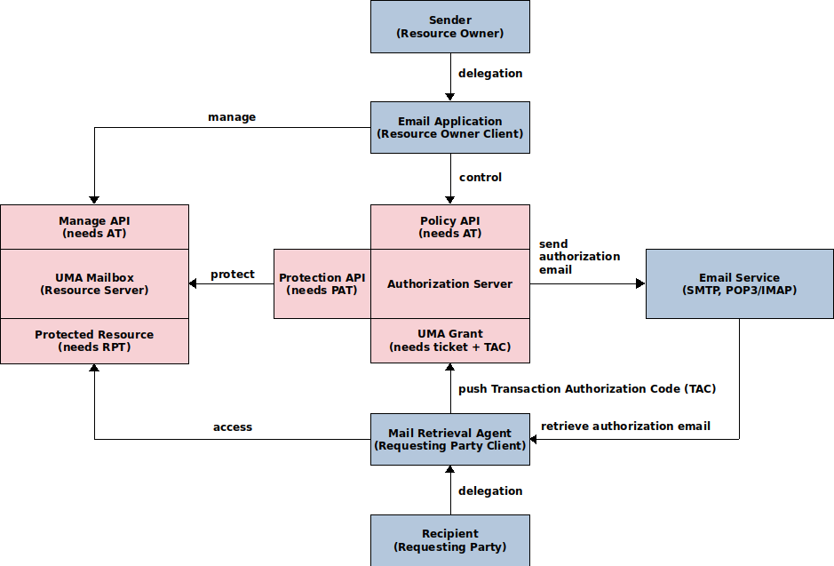
AEMS – schematic flow during the data transit from sender to recipient

Key points

- An email consists of resources (message and attachments) stored in an UMA Mailbox – an email-specific UMA Resource Server.
- The email resources owned by the sender stored in the sender’s UMA Mailbox are temporarily shared with the recipient. Following a successful sharing process, an authorization email with the transaction authorization code and the email resources identifier is sent to the recipient via the standard email system.
- The recipient’s Mail Retrieval Agent that acts on behalf of the recipient retrieves the authorization email, authenticates against the sender’s UMA Authorization Server, gets authorized access and downloads the email resources from the sender’s UMA Mailbox. The downloaded data are stored in the recipient's UMA Mailbox.

Advantages over Current Mail System

- Security and Privacy: User correspondence takes place between UMA Mailboxes. The mailbox of the standard email system becomes redundant and is only used for system (registration, authorization) emails. This architecture guarantees more control over potential security and privacy issues such as leakage of intellectual property or loss of confidential content and makes the system compatible with enterprise security policies.
- Usability: The UMA Mailbox is decoupled from the email address. This allows a user with a single email address to use simultaneously multiple UMA Mailboxes. To separate official, business, personal and healthcare correspondence, AEMS provides the flexibility for storing emails according to various criteria within an appropriate UMA Mailbox provider.
- Platform: With the capability to store, locate, send and receive any content including documents, images, audios and videos, the proposed solution can be considered a promising platform for Content Services.

